**Lutezine to Lute News 119 (October 2016): The Hunter's Career; Recercars of Rotta and Rossetto, more versions of Bacheler, Dowland and Une jeune fillette & Albert de Rippe Part 11: Fantasies 4 & 6**

**The Hunter's Career by William Basse[1]**

In Izaak Walton's *The Compleat Angler* of 1653(chapter III, p. 74),[2] Piscator says 'I'l promise you I'l sing a Song that was lately made at my (i.e. Walton's) request by Mr. *William Basse*; one that hath made the choice Songs of the *Hunter in his carrere*, and of *Tom of Bedlam,* and many others of note; and this, that I wil sing, is in praise of Angling.' William Basse (c.1583-1653) published poems from 1602 to 1653, and famously penned an elegy 'On Mr. Wm. Shakespeare'. So Basse presumably composed the text, and probably also the tune, for the ballad 'Maister Basse his Careere, or The new Hunting of the Hare' 'To a new Court tune' beginning 'Long ere the Morne expects the returne of Apollo from the Ocean Queene' first known from a broadside lacking music *c.*1620 (EBBA20213).[3] It is followed in the broadside by 'The Faulconers Hunting' 'To the tune of Basse his Careere' beginning 'Earely in the morne, when the night's overworne, and Apollo with his golden beames'. The text of 'Maister Basse his Careere' is also included in John Phillips *Sportive Wit: The Muses Merriment* of 1656 (pp. 64-65) as 'The Hunters Song' and in his *Wit and Drollery, Jovial Poems* 1682 (p. 64). The tune of the instrumental settings here for lute, cittern, mandore (the latter two arranged for lute) and keyboard in sources from the 1620s and later, is presumably the same tune used for the ballad as it fits the text. However, the tune and the ballad were known thirty years prior to publication of Walton's *Compleat Angler* which is hardly 'lately made', unless Walton had written his book years before it got to press. Other ballads were sung to what is probably the same tune, the earliest being 'Mount Taragh's Triumph, 5 Iuly 1626, to the tune of the Careere' beginning 'King Charles be thou blest, with peace and with rest' and printed in Dublin (Bod10646),[4] and see 'Wit's never good til tis bought, OR, Good counsell for improvident men, Fit to make use of now and then' 'To the tune of Basses Carrere' beginning 'Once musing alone, upon things many a one,' with the refrain 'That true wits never good till tis bought' and 'The second part, To the same tune' beginning 'In company base, that are voyd of all grace,' with the refrain 'Thus wits never good till tis bought' 1633-69 (EBBA30307). A later ballad from 1663-1674 is 'Huberts ghost. Or, an excellent spiritual dialogue between him and death a little before his departure, very comfortable for all Christians to hear or read a Ditty well known in the North The Tune is, Basses Carreer.' beginning 'Hubert What serpent is this' (Bod21554). Also known from the 1680s and 1690s is 'The Hast Bride-Groom, OR, The rarest sport that hath been try'd Between a lusty Bride-groom and his Bride' 'To the Tune of, Bass his Carrier: or Bow-Bells' (an alternative tune rather than another name for the same tune) beginning 'Come from the Temple away to the Bed, as the Merchant transports home his treasure' (EBBA21759, 30674 & 33310). 'News from Frost-Fair' is another ballad *c.*1681-1684, 'To the Tune of, Come from the Temple to his bed, &c' beginning 'Not many years ago There fell a mighty Snow' (EBBA35437), probably using the same tune as 'Come from the Temple to his bed' which is the first line of 'The Hast Bride-Groom', above. The tune was also used unnamed for a bawdy song 'The Hunt' in Thomas D'Urfey's *Pills to Purge Melancholy* vol. VI published in 1720 (pp. 197-198), the melody arranged here for lute.

[Additional: *Psalmes or Songs of Sion* 1642, no. 8. *My shepheard. ps. 23*. p. 9 tune: *The Hunters Careere*]

**C1.** GB-Lam 603 (Board), f. 27v *The Hunters Careere* p. 6

**C2.** GB-En Adv.5.2.18 (Straloch), pp. 16-17 *Hunters Careire* 6

**C3.** Och 437, f. 8v *humbers carrere* - arranged from keyboard 6

**C4.** *Pills* VI 1720, p. 197 *The Hunt* - arranged from melody 15

**C5ab.** GB-En Adv.5.2.15 (Skene), p. 235 *Hunters Carrier* - mandore and arranged for lute[5] 22 & 27

**C6ab.** GB-En 9450 (Edwards), f. 42r *The carrier* - cittern 25

**C7.** US-CAh 179 (Boteler), f. 18r *The hunters Careare* - cittern 73

**Recercars of Rotta and Il Rossetto**

In 1560 Canon Bernardinus Scardeonius of Padua wrote in his history of Padua and its citizens, that the Paduan **Antonio Rota** was an unrivalled Italian lutenist and teacher who died in 1549. In Venice in 1546 both Antonio Gardane and Girolamo Scotto published editions of a book of lute tablature with the same contents by *de l'Excellentissimo Musicho* (i.e. composer) *Antonio Rotta* (see title pages on p. 5 here).[6] The two editions are nearly identical but Gardane's print is more aesthetically pleasing with fewer mid-bar stave breaks and page turns and omitting the clutter of the many tenuto signs (#) in Scotto. Hans Radke's New Grove entry for Rotta claims Scardeonius refers to Rotta publishing lute instructions, and to quote Radke 'presumably meaning the appendix to Rotta’s *Intabolatura* (Venice, 1546), ‘Regula alli lettori’, an introduction to the lute based on Italian tablature'. No 'Regula alli lettori' is in fact found in the surviving copies of the two editions of Rotta's lute book, and the translation of Scardeonius kindly provided here by Matthias Rösel and Rainer aus dem Spring,[7] do not refer specifically to published instructions but rather 'to the orderly form of a printed book' most likely meaning the tablature book with its tenuto and fingering indications in the Scotto (although not the Gardano) edition that we know, suggesting Radke misinterpretted Scardeonius' meaning. Additional lute solos ascribed to Rotta are found in manuscript sources.[8] The lute book contains dances, vocal intabulations, and six recercars. The recercars are each ascribed 'A.R.' in Scotto (but not in Gardane) and so Rotta presumably composed them. They are outstanding examples of the genre in the generation after Francesco and all six are edited here. Closely concordant versions are found in a number of other manuscript and printed sources. Several of them were transcribed from Italian into French and German tablature for publication by Pierre Phalèse and Hans Gerle (the latter listing them collectively as *Anthoni Rotta hat fiere* in the index), respectively, both in 1552. Phalèse included some of them again in editions of *Theatrum Musicum* in 1563 and 1568, but not the 1571 edition. The Paduan Giovanni Pacalono copied recercar terzo into the Castelfranco Veneto manuscript dated 1565,[9] a few variants suggesting he copied them from neither the Scotto nor Gardane prints. Paul Hainhofer copied all six recercars into one of his lute books in 1604, which are identical to Scotto's edition including errors and minor variants.

**R1.** Gardane/Rotta 1546, sigs. I3v-I4r *46 Recercar primo* p. 7

[Scotto]/Rotta 1546, ff. 46r-46v *Reccerchar. A. R.*

Phalèse 1552, pp. 16-17 *Fantasia a Rota*

Gerle 1552, sigs. E4r-E4v *Das 16. Preambel Anthoni Rotta*

Phalèse 1563, f. 3r *Fantasia a Rota*

D-W Guelf 18.7 III, ff. 206r-206v *Reccerchar d'Anto Rotta*

**R2.** Gerle 1552, sigs. E4v-F1v *Das 17. Preambel* [*Anthoni Rotta*] 8

[Scotto]/Rotta 1546, ff. 47r-47v *Reccerchar. A. R.*

Gardane/Rotta 1546, sigs. I4r-I4v *47 Recercar segondo*

D-W Guelf 18.7 III, ff. 206v-207r *Reccerchar d'A. R.*

**R3.** Gardane/Rotta 1546, sig. K1r *48 Recercar terzo* 9

[Scotto]/Rotta 1546, ff. 48r-48v *Reccerchar. A. R.*

Phalèse 1552, p. 17 *Fantasia a Rota*

Gerle 1552, sigs. F2v-F3r *Das 19. Preambel*

Phalèse1563, f. 7r *Fantasia a Rota*

Phalèse1568, f. 11r *Fantasia*

D-W Guelf 18.7 III, ff. 207r-207v *Reccerchar d'Anto Rota*

I-CFVd w.s., f. 4r *Recercare: Rota Padoana*

**R4.** D-W Guelf 18.7 III, ff. 207v-208r *Reccerchar d'A. R.* 10-11

[Scotto]/Rotta 1546, f. 48v *Reccerchar. A. R.*

Gardane/Rotta 1546, sigs. K1v-K2r *49 Recercar qunto* [*sic*] [index: *quarto*]

Phalèse 1552, p. 4 *Fantasia a Rota*

Phalèse *Theatrum Musicum* 1563, f. 5r *Fantasia a Rota*

**R5.** Gardane/Rotta 1546, sigs. K2v-K3r *50 Recercar quinto* 12-13

[Scotto]/Rotta 1546, ff. 50r-51r *Reccerchar. A. R.*

Phalèse 1552, p. 15 *Fantasia a Rota*

Gerle 1552, sigs. F1v-F2v *Das 18. Preambel*

D-W Guelf 18.7 III, ff. 208r-209r *Reccerchar A. R.*

**R6.** [Scotto]/Rotta 1546, f. 51r *Reccerchar. A. R.* 14-15

Gardane/Rotta 1546, sigs. K3v-K4r *51 Recercar sexto*

D-W Guelf 18.7 III, ff. 209r-209v *Reccerchar d'A. R.*

**Domenicho Bianchini Veneziano detto Rossetto/Il Rosso**

**Dominicho Bianchini** Veneziano,[10] nicknamed Rossetto or Rosso presumably because he had red hair, was born *c.*1510 and was probably the son of the barber Giovanni Antonio del Bianchini in Udine, and was a master of the Venetian guild of mosaicists by 1537.[11] Mosaics by him, his brother and his nephew dated 1538 are at the Duomo in Pisa, and he produced mosaics for St. Mark's basilica in Venice between 1540 and 1576. Andrea Calmo included Bianchini together with Marco dall'Aquila and Francesco da Milano in a list of the prominent 'moderns' of the 16th-c,[12] and Girolamo Parabosco recorded that Bianchini played lute in an ensemble at a music event in Venice in 1544.[13] Antonio Gardane published a lute book *Intabolatura de Lauto di Dominico Bianchini ditto Rosetto* in 1546, which Gardane reprinted in 1554, and Girolamo Scotto reprinted in 1563 (see title pages on p. 5 here).[14] Two more lute solos ascribed to him are known in manuscript sources.[15] He was probably an amateur musician and arranger rather than composer born out by the fact that the settings of dances and the intabulations of vocal music in his printed lute book are pedestrian, and although the six recercars reproduced here are accomplished in their use of imitation, one is an arrangement of an ensemble recercar by Julio Segni da Modena and a different arrangement of another is found in the lute book of Maria da Crema. Arthur Ness has suggested that he probably arranged all of the rececars for lute from existing instrumental part music.[16] Closely concordant versions of some were transcribed from Italian into German tablature in Hans Gerle's 1552 print.

**B1.** Gerle 1552, sigs. C4v-D1v *Das 9. Preambel Rossetto* p. 16

Gardane/Bianchini 1546, sigs. A2r-A2v *1 PRIMO RECERCAR*

Gardane/Bianchini 1554, sigs. A2r-A2v *Recercar Primo*

Scotto/Bianchini 1563, pp. 3-4 *Recercar primo*

**B2a.** Gardane/Bianchini 1554, sigs. A2v-A3v *2 Recercar Segondo* 18

Gardane/Bianchini 1546, sigs. A2v-A3v *2 SEGONDO RECERCAR*

Scotto/Bianchini 1563, pp. 4-6 *Recercar Secondo*

**B2b.** Gardane/da Crema 1546, sigs. A4r-A4v *4 Recercar quarto* 19

[Scotto]/da Crema 1546, ff. 5r-5v *Recerchar Quarto*

Gerle 1552, sigs. B2v-B3v *Das 3. Preambel* [*Jo. Maria*]

Phalèse & Bellère *Theatrum Musicum Longe* 1571. f. 14r *Fantasia*

Instr. ens. à 4: Modena *Musica Nova* 1540, sig. O3r *R. Julio da Modena*;

Moderne *Musique de Joye* 1540s, sig. B2r *R. Julius de Modena*

**B3.** Gerle 1552, sigs. D2r-D2v *Das 11. Preambel* [*Rossetto*] 17

Gardane/Bianchini 1546, sigs. A3v-A4r *4 DVO*

Gardane/Bianchini 1554, sigs. A3v-A4r *Re. Terzo*

Scotto/Bianchini1563, pp. 6-7 *Recercar terzo*

**B4a.** Gardane/Bianchini 1554, sigs. A4r-A4v *Recercar Quarto* 20

Gardane/Bianchini 1546, sigs. A4r-A4v *3 TERZO RECERCA*

Scotto 1563, p. 8 *Recercar quarto*

**B4b.** [Scotto]/Barberiis IV 1546, ff. 17r-17v *Qui tollis peccata*

[Richafort] 21

**B5.** Gardane/Bianchini 1546, sig. D2r *19 RECERCAR* 22

Gerle 1552, sigs. D1v-D2r *Das 10. Preambel* [*Rossetto*]

Gardane/Bianchini 1554, sig. D2r *19 Recercar*

Scotto/Bianchini 1563, p. 27 *Recercar*

**B6.** Gardane/Bianchini 1546, sig. D4v *24 RECERCAR* [17] 23

Gardane/Bianchini 1554, sig. D4v *23 Recercar*

Scotto/Bianchini 1563, p. 32 *Recercar*

**John Dowland Alo - Continued**

One of the three versions of a set of variations on what is thought to be the ballad tune *The George Aloe and the Sweepstake,* from Mathew Holmes' manuscript Dd.5.78.3 was reproduced in the supplement to *Lute News* 119, and the other two known versions of Dowland's setting are included here. No other settings of the tune are known. The one in Euing is nearly identical to Dd.5.78.3 in *Lute News*, whereas the one in the Trumbull lute book differs in details of some of the suspensions and discordant phrases, with which the scribes of all three versions seem to have had some difficulty (see the commentary at the end of this *Lutezine*).

**JD68a.** GB-Cu Dd.5.78.3, ff. 38v-39r *J.D.* *Lute News*

**JD68b.** GB-Cu Add.8844 (Trumbull), f. 25r *Alo* 24-25

**JD68c.** GB-Gu Euing 25, ff. 21v-22r untitled 26-27

**Une jeune fillette**

John Dowland's setting (JD93) and one version of Daniel Bacheler's setting of this tune were in *Lute News* 119. The tune was used to set a variety of texts across Europe,[18] such as the song *Une jeune fillette* (There was a young girl ... made a nun against her will) in Jehan Chardavoine's *Recueil des plus belles et excellentes chansons* (Paris, Claude Micard 1576), ff. 135v-136v (see facsimile on p. 5),[19] *Ma belle, si ton âme* (My beautiful one if your soul, see no 50)[20] in France, *Maraen, hoe moogt gy spies en lans verheffen tegen God?* (Well then, how could you, facing God, see no 2) in the Netherlands, *Ich ging ein mal spazieren* (I once went walking, Den Briel *Een nieuw Geusen lieden boecxken* 1572/1581) and *Von Gott will ich nicht lassen* in Germany (I shall not abandon God, see no 23, 24 & 27),[21] *Madre non mi far Monaca* (mother do not make me a nun)[22] in Italy, and a variety of other texts were also set to it. Several of the texts relate the story of girls lamenting their parents sending them to a nunnery because they cannot afford a dowry to marry them off. The tune was hugely popular in the sixteenth and seventeenth centuries and sets of variations on it were composed for lute and other instruments using the titles of the various texts, as well as *Almande Nonette* (that is an almande for a young nun) in The Low Countries, the first of the latter published by Phalèse in 1568, and *La Monaca* and *La Alemana* in Italy. The other version of Bacheler's setting (DB41b) together and all fifty other arrangements for lute (in F, G, C and D minor) and cittern known to me (apart from those titled *La Monaca* and *La Alemana* - but see no 12 here - are to be included in a later *Lutezine*) are included here. The settings are all different (apart from no 4=6, 12=13, 17=18, 34=35, 39=40=41 and the B strain of no 5 is the same as the B strain of the lute accompaniment to the song no 50), to suit all purposes and standards of ability, from simple shorter settings for beginners (e.g. no 1, 20, 24) to elaborate extended variations for the virtuosi (e.g. no 4, 8/10, 15). Besard's *Novus Partus* of 1617 includes a consort setting à 5 for lute trio plus superius and bass for two melody instruments, and the lute parts are reproduced here (no 43a-c) without any attempt to fit them together. The many settings are mostly anonymous with just a few composer or arrangers named: John Dowland, Daniel Bacheler and Jacob Polak (no 8) with a concluding variation by Joachim van den Hove (no 10), as well as Balahart (no 19), presumably Robert Ballard, and Besard, Jobin, Phalèse, Waissel, Valerius (separate settings for lute, cittern and voices) and Vallet probably made the arrangements for their prints (no 2, 4, 15 & 43). No 47 is a setting by M. N., presumably Melchior Neusidler, of a different tune that only begins the same. Also the common time tune is followed by a triple time reprinse or nach dantz in some German sources (no 40-42), and two other settings are in triple time and titled courante. Three settings for diatonic cittern in french tuning plus transcriptions for chromatic cittern in italian tuning, are also included. Curiously, a considerable number of bars are shared between settings ostensibly by Bacheler (in the longer set of seven variations DB41b, but not the shorter 5-variation set DB41a) and Dowland (JD93), as well as some of the continental settings. Thus, DB41b bars 112-143 are virtually identical (apart from rhythm signs doubled in length) to JD93 bars 111-174, and some of these bars are also found in Jacob Polak's setting in Hove 1612 (bars 40-45 of no 8 here) and two settings in 40032 (bars 25-39 of no 12 & 13).[23] Also different bars are shared between the settings by Jacob Polak (no 8 bars 56-79, 17-22 & 57-60) and Jean-Baptiste Besard (no 4 bars 25-48, 49-55 & 88-91, respectively), and in a smaller section between bars 1-3 and 33-35 of no 8 and bars 9-14 of no 12 & 13, and probably more.

[Additonal: See John M Ward 'Music for "A Handefull of pleasant delites"' *Journal of the American Musicological Society* 10/3 (Autumn, 1957), p. 175 fn 85. Camphuysen *Stichtelijke Rijmen Tweede Deel* 1647, pp. 140-143 *Sang: Une Ieune fillette*. 'Gyvraege my of ick self bellef al wat ick seg'. D-W Guelf. 18.8, f. 21v *Deutscher Dantz - Nachdantz* (text: *Aines mahlss het ich spatziern ain weeglein klain*)]

**JD93.** D-Hs ND VI 3238, pp. 25-28 *Del Excellentissimo.*

*Musico Jano Dulando. Andegaui, Anno 1614.* *Lute News*

**DB41(a).** GB-Lbl Eg.2046, ff. 30v-31r untitled *Lute News*

**DB41b.** GB-Cfm 689, ff. 23v-25r *La ieune fillette mr Daniel* pp. 28-32

**1.** D-B Danzig 4022, f. 47r untitled 33

**2.** Valerius 1626, p. 180 *Almande Nonette* - *Une Jeusne fillette* 33

**3.** D-Kl 4° Mus. 108.1, ff. 11v-12r *Ballet* 342

**4.** Besard *Thes Harm* 1603, ff. 131v-132r *Alemande Vne Ieune fillette* 35-37

**5.** PL-Kj Mus.40143, f. 25r *Vne jeune fillette 14. Novemb* 37

**6.** PL-Kj Mus.40143, ff. 35v-37v *Une jeune fillette* 38-40

**7.** NL-Lu 1666, f. 380r *Vne jeune fillette* 40

**8.** Hove 1612, ff. 55v-56v *Vne Ieune Fillette. Mr Iacques Pollonis*

- PolakP[24] pp. 147-156 & HoveB[25] 389 41-44

**9.** D-Lr Mus.ant.pract.2000, p. 58 *Pavane* 44

**10.** Hove 1612, ff. 56v-57r [Vne Ieune Fillette] *Ultima Parte.*

*Joachimus vanden Hove* - HoveB 275 45

**11.** LT-Va 285-MF-LXXIX, f. 2v untitled 46-47

**12.** PL-Kj Mus. ms. 40032, pp. 382-385 *La Monacha ballo francese* 47-51

**13.** PL-Kj Mus. ms. 40032, pp. 366-367 *Una fillete Cançon françois* 52

**14.** PL-Kj Mus. ms. 40032, pp. 382-385 *Juna fillette chancon francoys* 53

**15.** Vallet 1615, pp. 43-44 *Vne Jeune fillette A.9*. 54-55

**16.** D-Ngm 33748/I, f. 66v *Ballet* 56

**17.** PL-Kj Mus.40143, f. 35r *16 Martij. 1601 Courr.*

*sur la voix de La jeune fitte* 56

**18.** GB-HAdolmetsch II.B.1, ff. 64v-65r *Courante* 57

**19.** B-Br II.275, f. 100v *Gagliarda di Monsu Balaharta* 58

**20.** D-BAU Druck 13.4°.85, p. 18 *Vne Jeune fillette* 59

**21.** NL-Lu 1666, f. 380v untitled 59

**22.** US-DMu MS E 19454,[26] f. 1v untitled 60-61

**23.** D-LEm II.6.15, p. 528 *Von Gott will ich nicht lassen* 61

**24.** D-LEm II.6.15, p. 540 *Von Gott will ich nicht lassen* 62

**25.** NL-Lu 1666, f. 509r *Allemande Nonette* 62

**26.** D-W Guelf 18.3 IV, ff. 21v-22r *Deutscher Dantz*

[text: *Ains mahls thet ich spazieren*] 63

**27.** LT-Va 285-MF-LXXIX, f. 42v *Von gott will Ich nicht lassen* 64

**28.** CH-Bu F.IX.70, pp. 281-282 *Ich gieng einmal spazierenn* 64

**29.** CZ-Pnm XIII.B.237, no. 9 *Ich ging einmal spatziren* 65

**30.** GB-WPforester-welde, f. 6v *Away I have forsworne her Company* 65

**31.** Waissel 1573, sig. M2r *Tantz Sprunck* 66

**32.** Phalèse 1568, f. 88r *Almande Nonette. Reprinse* 67

**33.** Adriaenssen 1584, f. 88r *Almande Nonnette* 68

= Adriaenssen PM1600, f. 72r *Almande Nonette*

**34.** Phalèse & Bellère 1574, f. 80r *Almande la nonette* 69

**35.** GB-Ob D.4.10 Art. (mss adds Phalèse 1563), f. 1r *Almande Nonette* 69

**36.** GB-Eu Dc.5.125, f, 25r untitled 69

**37.** I-BDGchilesotti, p. 225, *Ich gieng ein mage Bayieren* 70

**38ab.** Valerius 1626, pp. 180-181 *Stem: Almande Nonette, Of: Vne Juesne*

*fillette* - diatonic cittern and transcription for chromatic cittern 70-71

**39.** D-Mbs 266, ff. 109r-109v *Ich ging ein mal spatsieren ein Wege Hupffauf* 71

**40.** Neusidler 1574, sigs. K1v-K2r *Ich gieng ein mal spacieren/ Volget der Hupffauff* 72-73

**41.** PL-Kj W510, ff. 30v-32r *Ich gieng ein mal spacieren - Nach dantz* 74-75

**42.** Jobin 1573, sigs. F2r–F2v *Teutscher Dantz Nach dantz* 75-76

**43a.** Besard *NP* 1617. sigs. D2r *Vne Jeune fillette I.B.B. Testvdo Minor* p. 77

**43b.** Besard 1617. sigs. D1v *Vne Jeune fillette I.B.B Nova Testvdo* 78

**43c.** Besard 1617. sigs. D1v *Vne Jeune fillette Testvdo Maior* 79

**44.** D-Sl G.I.4 I, f. 40r *Ich gieng ein mal spazieren* 80

**45.** IRL-Dtc 410/1, p. 213 *the kinge of Africa* 80

**46.** CH-Bu F.IX.70, p. 268 *Ich gieng ein mal spatzieren Saltus* 81

**47.** D-Sl G.I.4 I, ff. 40v-41r *Teutscher dantz M*[elchior?]*. N*[eusidler?]*. Hupffauf* 82-83

**48ab.** Phalèse & Bellère *Hortus Citharae* 1582, ff. 70v–71r *Almande de la Nonette - Reprinse* - diatonic cittern & trans. for chromatic cittern 84-85

**49ab.** Kargel *Renovata Cythara* 1578,[27] sig. M1r *Almande Ich ging ainmal spaciren* - diatonic cittern & transcription for chromatic cittern 86-87

**50.** Besard 1603, f. 73r *Ma belle, si ton âme* - lute and voice[28] 88

Keyboard setting: GB-Lbl Add.29485 (Soldt), f. 4r *almande de la nonette*

[Additional: Calvi 1646, p. 34 *Allemana* - guitar; Waissel 1591, sig. B3r 5. *Tantz Sprung*; CH-Bu F.IX.70, p. 264 *Dantz* ?; I-PESo P XVII.21 [2-34], 4 settings i171-187 untitled; Phalèse TM1563, f. 63r *Gepeis ghij doet mij trueren*; Phalèse TM1563, f. 63r *Gepeis ghij doet mij trueren*; D-Dl 1.V.8, ff. 45v-45r *Allemande*; cf. IRL-Dtc 410/I, f. 71 ii *Passingmease*]

**En me revenant - addendum**

Daniel Bacheler's settings of *En me revenant* was edited for *Lute News* 115 (October 2014) and all the other arrangements known to me were in the accompanying *Lutezine*. However, thank you to Michael Belotti for pointing out that I had omitted the anonymous setting in the Harling lute book, included here as App 1. Also thank you to Andreas Schlegel for noticing an error in one of the settings in the manuscript CH-SO DA 111 (my no 42). I did not see that it is for an 11-course lute as the scribe notated both the 10th and the 11th courses as ///a, so a revised version is here with the diapasons notated with numbers, 7 for 7th in F, 8 for 8Eflat, 9 for 9D, 10 for 10C and 11 for 11Bflat.

**App 1.** D-Lr 2000 (Harling), p. 10 *Ballet* 83

**App 2.** CH-SO DA 111, ff. 33v-34r *En reuenant de St. Nicolas A D: Jacobo Murer* - REVISED 89

**Daniel Bacheler Pavans continued**

One version each of Daniel Bacheler's pavans DB10-15, the paired galliard to one of them DB13b, and a pavan of doubtful attribution were edited in *Lute News* 119. Three of them, DB11, 12 & 15, are unique versions, and the additional versions of DB10, 13a, 13b and 14 are edited here with commentary for all versions at the end of this *Lutezine*. All of the additional versions are for a lute with a 7th course tuned to D (assuming G pitch), except the Herbert version of DB 10 requires a 7th in F and 8th in D. After regularisation and amendment to the rhythm signs and barring as well as changing a few possible errors in tablature letters, it is clear that the different versions of the pavans are all closely concordant (except DB13a-e, see below), with minor but significant variants. The versions of DB10 and DB13 from the Herbert lute bookwere both copied by Edward Herbert, and then later amended with variants and a few corrections by another hand, thought to be Bacheler himself.[29] Both the original and altered versions are edited here separately. A curious feature consistent between the four versions of **DB10** (including the original and altered ones in Herbert) is the difference in numbers of bars between the first statement and the divisions of the B and C strains. A bar is inserted in the division between the 13th and 14th bars of the B strain extending the imitation of the previous bar. Then in the C strain, two bars are inserted in the division, one between the 9th and 10th bars of the strain that seems to be a repetition of the previous bar; the second is inserted between the 13th and 14th bars extending the final cadence. All five versions of the pavan **DB13a** have A/B/C strains of 12, 13 and 14 bars, except that the version Herbert copied initially increased the B and C strains to 14 and 15 bars by extending the cadences in the penultimate bars of the strain and division. However, in the altered version the extra bar in the B but not the C strain was crossed out, suggesting the irregularities were intentional rather than copying errors. After much amendment of errors the version of DB13a from Fuhrmann's print is closest to Holmes's Dd.5.78 version. The pavan from Mylius (DB13a-e) is related but quite different to the others: it is concordant only in bars 1-3 of the A and 1-2 of the C strains, but uses a similar melodic contour and harmony here and there with figuration typical of Bacheler. The attribution to Wilhelmi Angli (William Brade?) and the awkward division writing in places suggest it was a poor copy or else that Wilhelmi copied it incorrectly. The two version of the galliard **DB13b**, one in *Lute News* 119 and theother here are nearly identical with minor differences in figuration especially use of the 7th course in bars 45-46. It is noteworthy that Mathew Holmes copied very similar but not identical versions of **DB14** into three of his manuscripts. The different versions of Bacheler pavans here do not offer much variety of settings, but all versions are edited here for comparison.

**DB10a.** GB-Cu Dd.9.33, ff. 70v-71v *Dan Bach* *Lute News*

**DB10bi.** GB-Cfm Mus.689, ff. 4v-5r *Pauana del medesimo* (Sr Danielli Inglese) - as copied by Holmes pp. 90-92

**DB10bii.** - as altered92-94

**DB10c.** #GB-Cu Add.3056, ff. 80v-81r *D Bacheler* 95-97

**DB13a-a.** GB-Lbl Eg.2046, f. 27v *A pauin by Mr Daniell Bachler* *Lute News*

**DB13a-bi.** GB-Cfm Mus.689, ff. 3v-4r *Pauana del Sr Danielli Inglese* - as copied by Holmes 97-99

**DB13a-bii.** - as altered by a different scribe (Bacheler himself?) 99-101

**DB13a-c.** *GB-Cu Dd.5.78.3, f. 61v-62r untitled 101-103

**DB13a-d.** Fuhrmann *Testudo Gallo-Germanica* 1615, p. 49-50 *Pavana prima.* [header: *Pavana de Angleterra*] 103-105

**DB13a-e.** Mylius *Thesaurus Gratiarum* 1622, p. 46-47 *Pauana Anglica. Ejusdem. 2* (Wilhelmi Angli) 105-107

**DB13b-a.** GB-Cu Add.3056, f. 82v *Ga*[lliard] *to the pauan before.* *Lute News*

**DB13b-b**. GB-Cu Dd.5.78.3, f. 58r (Galliard) *D B.*

*turn 4 leaues back for ye paven* 107

**DB14a.** GB-Cu Nn.6.36, ff. 38v-39r *Mr D B* *Lute News*

**DB14b.** GB-Cu Dd.5.78.3, ff. 72v-73r *Daniell Bacheler* 109-111

**DB14c.** GB-Cu Dd.9.33, ff. 40v-41r *D Bac* 111-113

**Fair Mistress disdain me not**

This tune setting in the Margaret Board lute book is followed by what is probably the text to a song/ballad to sing to it, as it fits the tune if the first two strains but not the third are repeated. However, I have found no other reference to the text or other use of the tune.

*Fayre mysters disdayne me not* *though hard / fauored I be /*

*For Venus did w(i)th w(hi)ch can match yer non / so foule as he /*

*In Vayne you Vrge that text / What Vlcan was I knowe /*

*What yf he weare a cockold made would be serued so.*

**F1.** GB-Lam 603, f. 23v *Fayre mysters disdayne me not* 107

**Have at thy Coat old woman - continued**

Playford's cittern and violin settings of this tune were in *Lute News*, but he including common and triple time settings and a number of variants in later editions, and so all five are arranged here, as well as a lute arrangement of the violin setting from Walsh's *The Compleat Country Dancing Master*. A lute setting in English Gauthier tuning from the Board lute book is also included here, together with a transcription for renaissance lute.

**H2b-e.** Playford *The Dancing Master*, p. 38 *Have at thy Coat old woman*

- five variant versions from 1st (1651) 2nd (1652), 3rd ([1657]/1665),

9th (1695) & 17th (1721) editions - arranged from violin 114

**H3a.** GB-Lam 603, f. 38r *have at thie coate old wom*(an) - (edeff) 115

**H3b.** - transcribed for renaissance lute. 115

**H4.** Walsh 1718 I, p. 204 *Have at thy Coat old Woman* - arranged from violin 115

**Albert De Rippe/Alberto Ripa**[30]

This supplement ends with the tenth part in the series of complete fantasies of Alberto da Ripa/Albert de Rippe, reproducing the fourth and sixth of the six fantasies in Fezandat's first volume, published in 1552 and reprinted with identical tablature in 1553.[31] Rippe 4 is very long at 414 bars and has the feel off a pastiche of a collection of Ripa's melodic ideas strung together including faster quaver passages uncharacteristic of most his other fantaisies. At 113 bars Rippe 6 is more concise with many characteristic Ripa traits, and includes bars shared with other de Rippe fantasies,[32] as well as with Francesco fantasias,[33] and is the more appealing of the two here so it is surprising that only Rippe 4 and not Rippe 6 has been recorded to my knowledge.[34]

**R4.** Fezandet I 15528, ff. 11r-17r *F*[antasie] [index: *La quatriesme fant.*]

= Fezandat I 15538, ff. 11r-17r *Fantasie* 116-121

**R6.** Fezandet I 15528, ff. 18r-20r *F*[antasie] [index: *La sixiesme fant*.]

= Fezandat I 15538, ff. 18r-20r *Fantasie* 122-123

*John H. Robinson - October 2016*

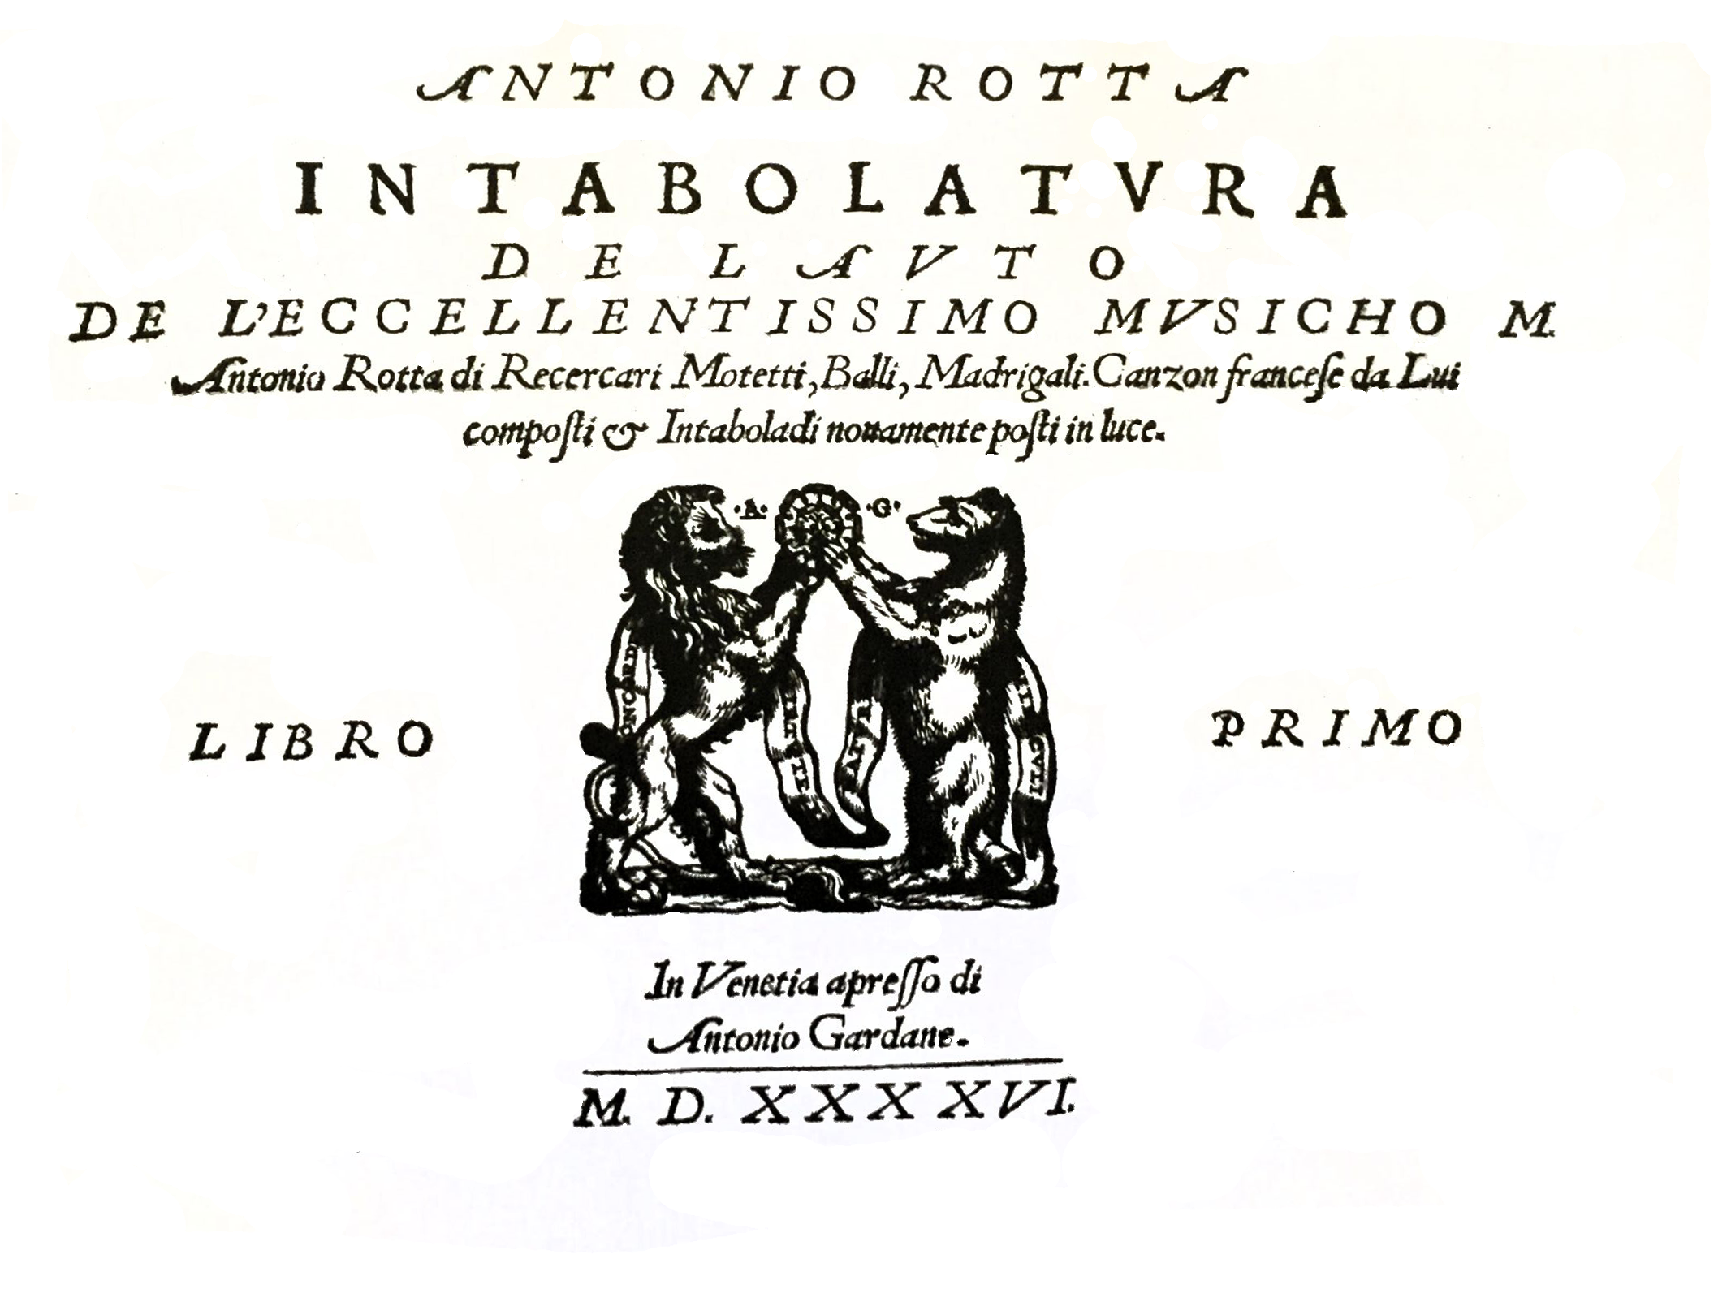

Gardane/Rotta 1546

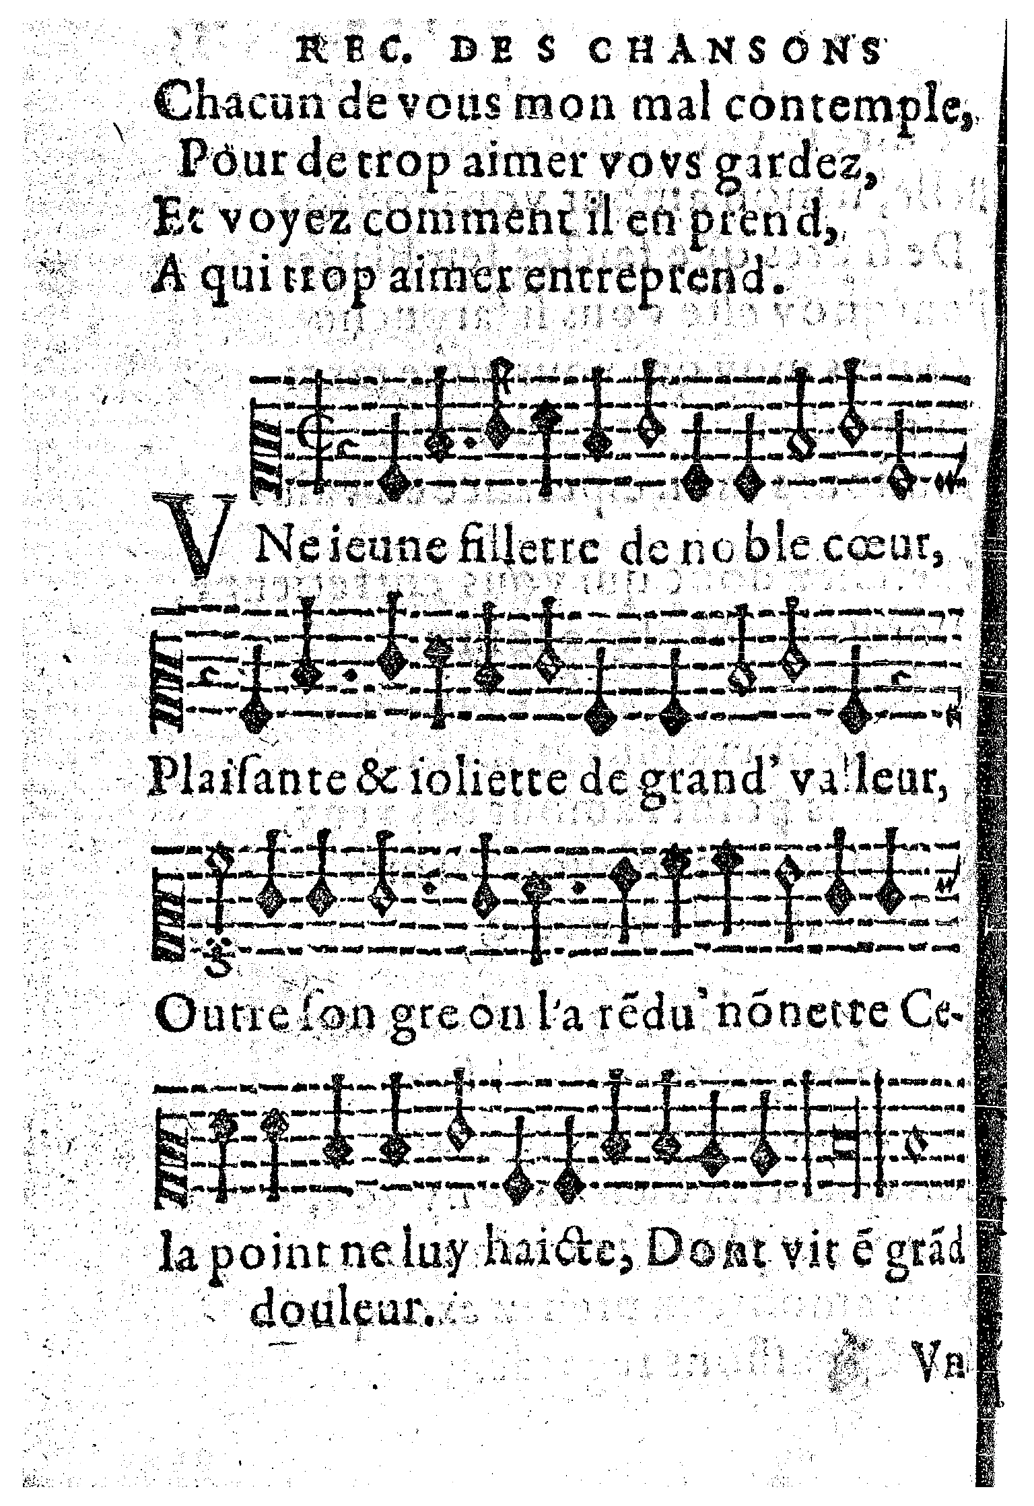

Chardavoine 1576, f. 135v

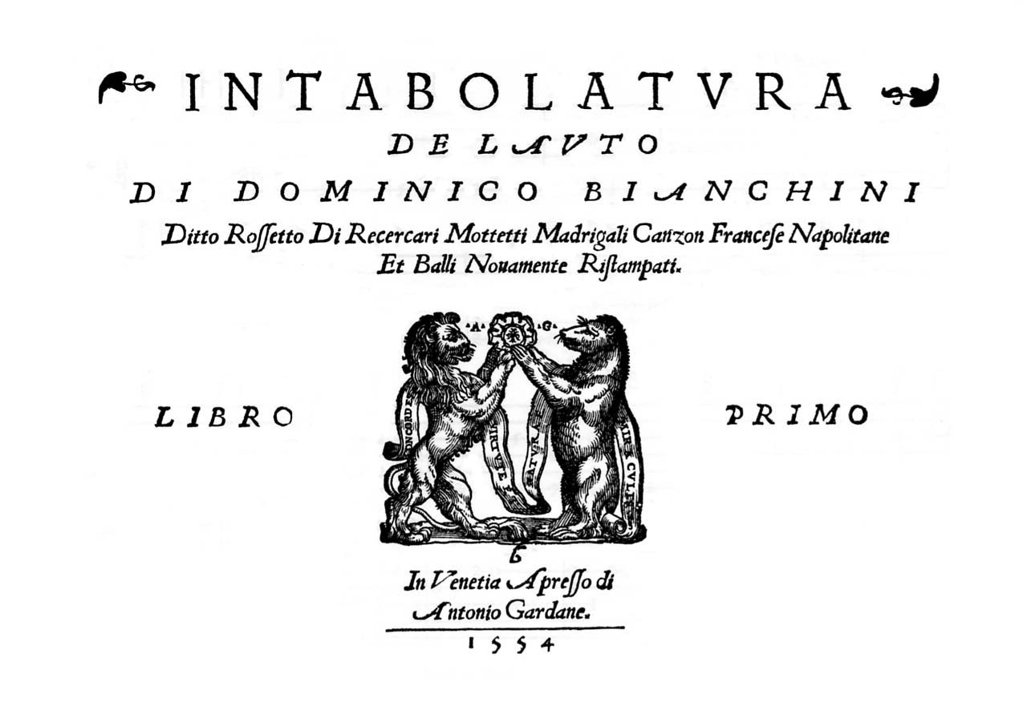

Gardane/Bianchini 1554

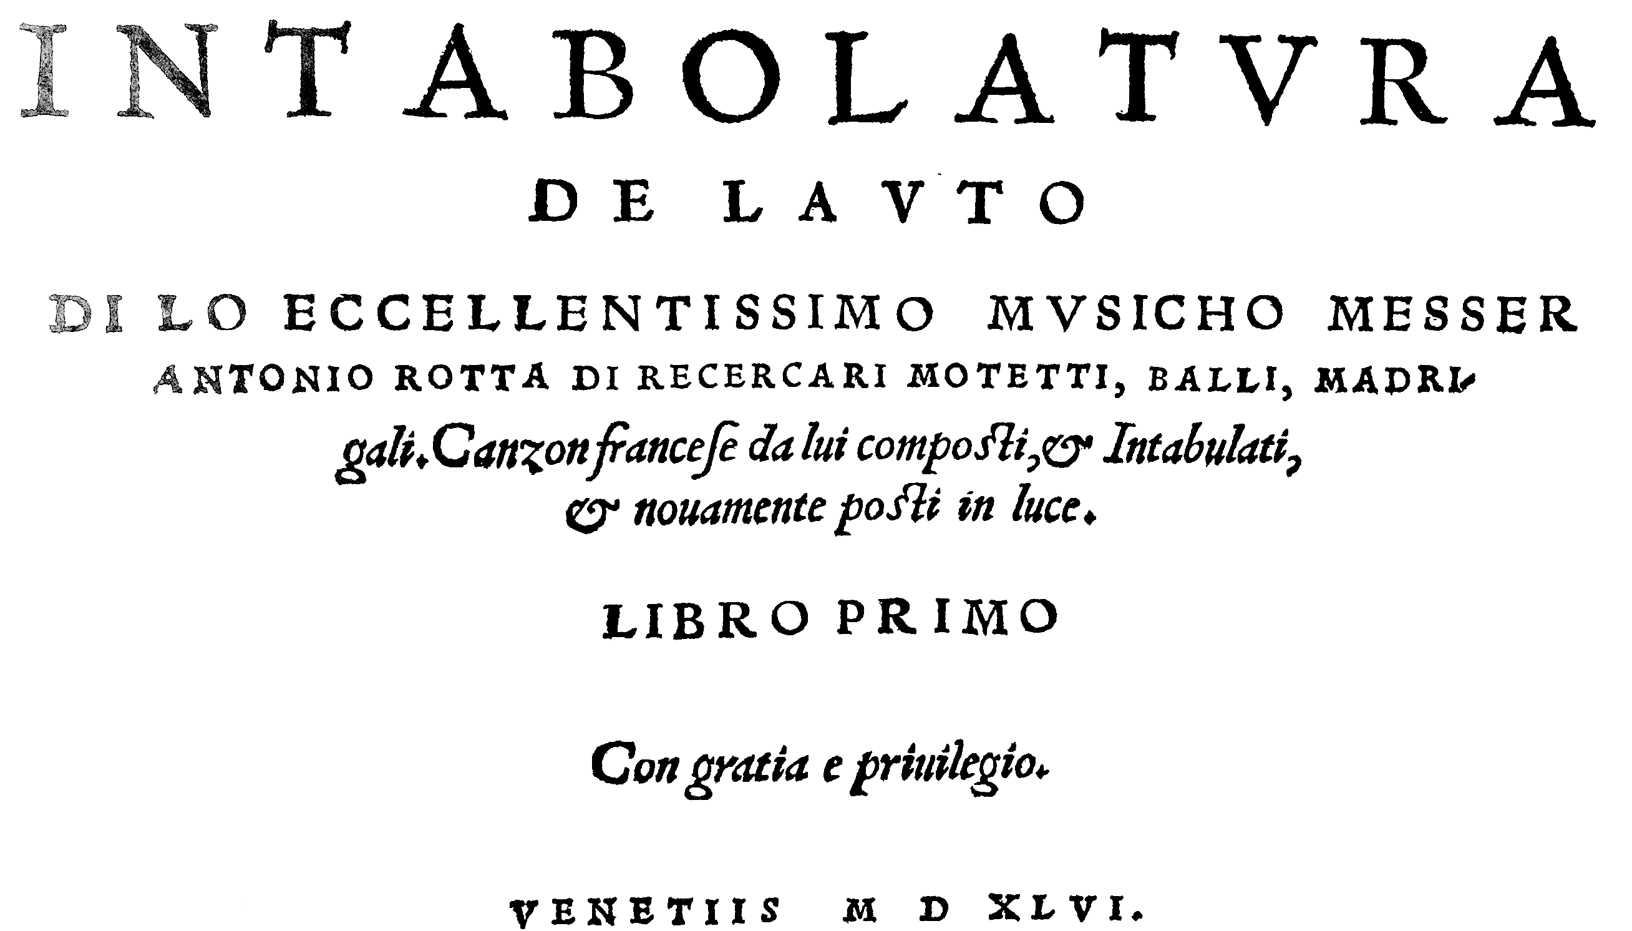

Scotto/Rotta 1546

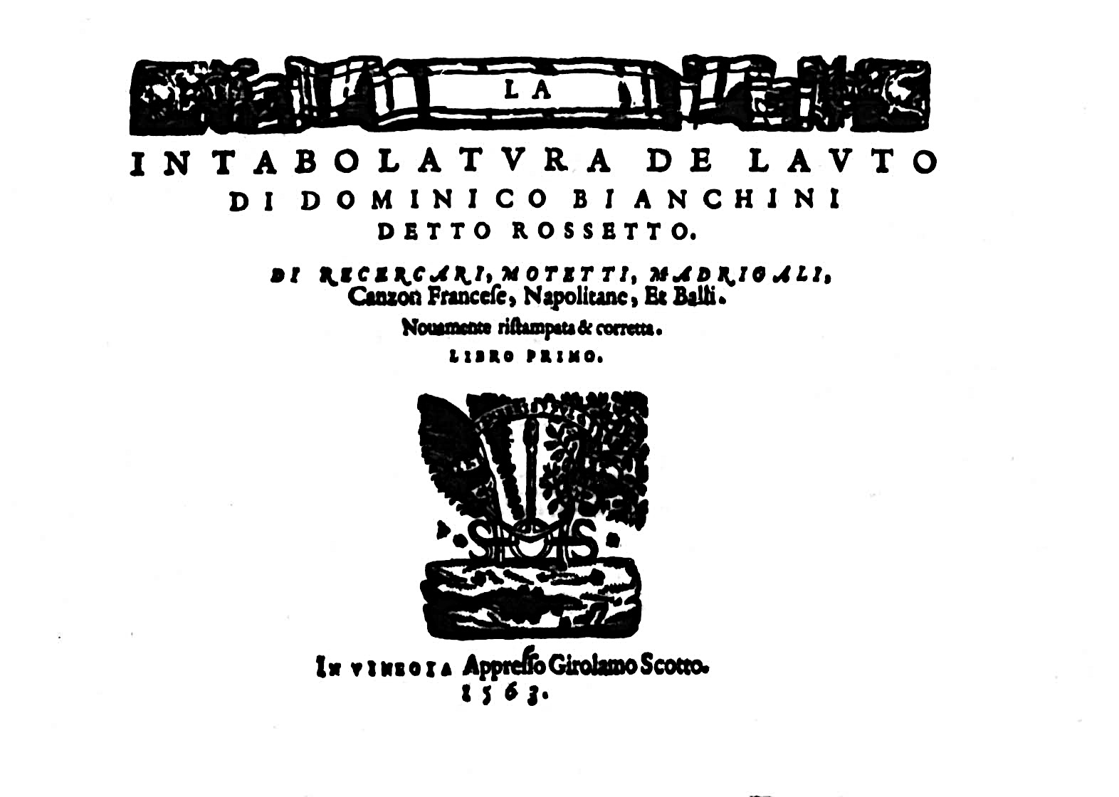

Scotto/Bianchini 1563

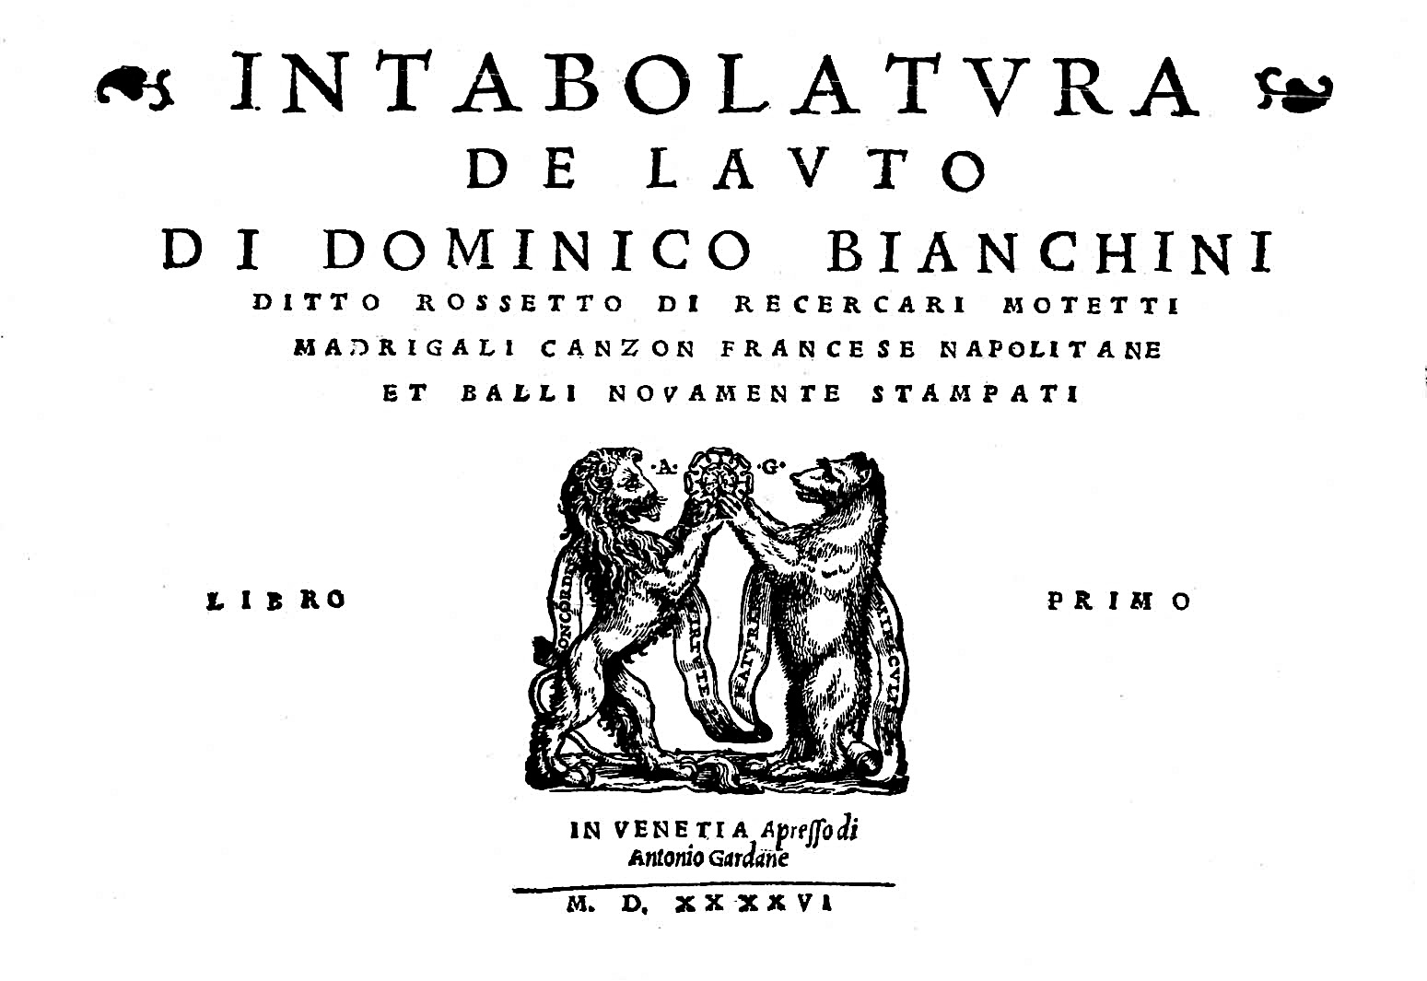

Gardane/Bianchini 1546

1. A commentary to the tablature in *Lute News* as well as to the Dowland, Bacheler and Ripa pieces are on pp. 124-125; there is no commentary for the rest of the music here, but changes are shown in grey.

   William Chappell *Popular Music of the Olden Time* 1855-6, part I, p. 255; William Chappell, revised H. Ellis Woolridge *Old English Popular Music* (London, Macmillan, 1893/reprinted New York 1961), part I, pp. 198-199; Claude M. Simpson *The British Broadside Ballad & Its Music* (New Brunswick, Rutgers University Press 1966), pp. 37-39.
2. See [http://www.biodiversitylibrary.org/item/74569 - page/14/mode/1up](http://www.biodiversitylibrary.org/item/74569#page/14/mode/1up) for online facsimile.
3. English Broadside Ballad Archive: <http://ebba.english.ucsb.edu>
4. Broadside Ballads Online at the Bodleian Libraries:

   <http://ballads.bodleian.ox.ac.uk>
5. Arranged for lute in *Music from Scotland* (Seicento 2012), p. 3.
6. *Intabolatura de Lauto di lo excellentissimo musicho Messer Antonio Rotta* (Venice [Scotto] 1546) - copies: A-Wn; B-Br; D-Mbs; F-Pn (facsimile: Minkoff 1982; http://gallica.bnf.fr/ark:/12148/bpt6k45002295); US-Cn; *Intabola-tura de Lauto de l'excellentissimo musicho Antonio Rotta* (Venice, Gardane 1546) - copies: D-Mbs (Tree 2013); D-Ngm; GB-Lbl; Gerle *Eyn Newes sehr Künstlichs Lautenbuch* (facsimile: Cornetto 1997); Phalèse *Hortus Musarum* (Tree 2014); Phalèse *Theatrum Musicum* 1563 (Minkoff 2005), 1568 (Minkoff 1983); I-CFVd w.s. (Forni 2012); D-W Guelf 18.7 III – see: <http://diglib.hab.de/wdb.php?dir=mss%2F18-7-aug-2f&pointer=0>
7. *De antiquitate urbis Patavii, & claris civibus Patavinis* (Basle, 1560): Historiae Patavinae Lib. II. Class XII. De Claris Musicis Patavinus. column 295: *De Antonio Rota, / Non tacendus est hic omnino Antonius Rota, nobilissimus sidcen: qui in pulsando liutum in Italia eruditorum judicio, vix parem habuit: neque artem hanc scivit solum, sed quod majus est, unus prae caeteris eximius praeceptor extitit, qui pro mercede eam ipsam docendo satis dives evasit. Edidit de ea re praecepta notabilia, quae in volumen redacta & impressa, ubique habentur, fidium stidiosis ad perdiscendam artem valde necessaria, & exinde admodum grata. Moritur anno M.D.XLVIIII. & apud Eremitanos sepelitur*. Translation by Matthias Rösel and Rainer aus dem Spring: One must by all means speak of Antonio Rotta, the most noble lute player. There was scarcely anybody like him, according to experts' opinion. Also, he was not only knowledgeable about this art but, what's more, he was the only teacher to excel before others, who preferred instructing to salary, considering the former wealth. He published his remarkable teachings in the orderly form of a printed book, that can be acquired anywhere. It is most useful to students of plucked instruments so as to thoroughly learn the art, and is warmly welcomed. He died in 1549 and is buried with the hermits (i.e. at the Church of the Eremitani, in Padua, see (thanks to Rainer aus dem Spring): <https://en.wikipedia.org/wiki/Church_of_the_Eremitani>).
8. Denys Stephens 'Music by Antonio Rotta in Manuscript Sources' *Lute Society of America Quarterly* 44/3 (Fall 2009) pp. 28-39.
9. This page of the manuscript is damaged, but see my 'Reconstruction of Music from Damaged Pages of the Castelfranco Veneto Manuscript' *Lute Society of America Quarterly* 49/2 & 3 (Summer & Fall 2014), pp. 38-48.
10. Not to be confused with Francescho Bianchini Venetiano, whose lute book *Tabulature de Lutz* was published by Jacques Moderne in Lyon in 1549 (Tree facsimile, 2010).
11. New Grove Online: Arthur Ness 'Bianchini [Bianchini Veneziano], Domenico [‘il Rossetto’, ‘il Rosso’]'
12. Le lettere de messer Andrea Calmo, Vittorio Rossi (ed.) (Turin, Ermanno Loescher, 1888), p. 295.
13. Quoted in the *Dialogo della musica* of Antonio Doni in 1544.
14. *Intabolatura de Lauto di Dominico Bianchini ditto Rosetto di Recercare Motetti Madrigali Canzon Francese Napolitane et Balli novamente Ristampati Libro Primo* (Venetia: Antonio Gardane 1546) - copies in D-Ngm (Paffgen 1977); GB-Lbl (<https://repository.royalholloway.ac.uk/items/ce33fc18-ae59-e924-b855-29cd26255b92/1/>); US-Wc, a copy was in PL-S and the Wolfheim Library; *Intabolatura de Lauto di Dominico Bianchini ditto Rosetto di Recercare Motetti Madrigali Canzon Francese Napolitane et Balli novamente stampati Libro Primo* (Venetia: Antonio Gardane 1554) - copies in A-Wn; F-Pn (2 copies?) (Minkoff 1982); *La Intabolatura de Lauto di Dominico Biachini detto Rosetto di Recercare, Motetti, Madrigali, Canzon Francese Napolitane et Balli. Novamente ristampata & corretta Libro Primo* (Venetia: Girolamo Scotto 1563) - copy in A-Wn. See

    <https://magnatune.com/artists/albums/rmackenzie-bianchini?song=1> for Richard MacKenzie's CD of the complete book: (Magnature 2012). Keyboard transcriptions of a dance from each of Rotta and Bianchini's lute books are found in the Jan of Lublin keyboard tablature book (PL-Kp 1716, 1537-1548, ff. 188r-188v), see John R. White 'Original compositions and arrangements in the Lublin keyboard tablature' in: *Essays in Musicology, a birthday offering for Willi Apel* Hans Tischler (ed.) (Bloomington, Indiana: Indiana University 1968), 83-93.
15. An intabulation of a motet titled *Creator omnium* *5 Voc. Adrian Willart. Domino Rossetto* in D-Sl G.I.4/II (*c.*1580-95), ff. 53v-54r, and a *Bregantin da M*(esser) *Rosso* in D-Mbs 1511d (*c.*1550), f. 14r and untitled in D-Mbs 1511b (*c.*1550), f. 16v.
16. Arthur J. Ness ‘Domenico Bianchini: Some Recent Findings’ in: Vaccaro (ed.) *Le Luth et sa musique II* (Paris, CNRS, 1984), pp. 97-111.
17. Opening theme parodies Josquin's Fault d'argent, as does da Rippe fantasie 9 (edited in the *Lutezine* to *Lute News* 117 (April 2016).
18. First stanzas at: <http://www.medieval.org/emfaq/misc/fillette.htm>
19. The full text from Chardavoine is:

    1 Une ieune fillette 2 Un soir apres complie

    de noble coeur, Seulette estoit

    Plaisante & joliette En grand melancolie

    de grand' valeur, Se tourmentoit,

    Outre son gre on Disant ainsi,

    l'a re[n]du' non[n]ette douce vierge Marie

    Ce la point ne luy haicte, Abregez moy la vie,

    Dont vit é gra[n]d douleur. Puis que mourrir je doy.

    3 Mon pauvre coeur souspire 4 Que ne m'a ton donnee

    Incessament, A mon loyal amy,

    Aussi ma mort desire Qui tant ma desiree

    Tourenellement. Au si ay je moy luy,

    Qu'a mes parens Touce la nuict

    my tien droit embrassee

    ne puis mander n'escrire, Me disant sa pensee

    Ma beauté fore empire, Et moy la mien ne à luy

    Le viz en grand tourment, Dieu vous dy mon pere,

    5 Ma mere & mes parens, 6 La mort est fort eruelle

    Qui m'avez voulu feire, A endurer,

    Nonnette en ce couvent. Combien qu'il faut par elle

    Ou il n'ya poins Trestous passer.

    de resiovissance, Encor' est plus le gra[n]d

    Je vis en desplaisance mal que j'endure

    Je n'attens que la morte. Et la peine plus dure

    Qu'il me faut supporter.

    7 A Dieu vous dy les filles -> De mon pays,

    Puis qu'en c'est Abbaye Me faut mourir,

    En attendant de mon Dieu la sentence

    Je vi en esperance D'en avoir reconsort,
20. Full text for the lute song from Besard's *Thesaurus Harmonicus*:

    1 Ma belle si ton ame 2 Avant qua la journée

    se sent or, allumer De nostre aage qui fuit

    de ceste douce flame Se sente environnée

    qui nous force d'aymer[.] Des ombres de la nuit,

    Allons contans Prenons loysir.

    allons sur la verdure De vivre nostre vie,

    allons tandis que dure Et sans craindre l'enuie

    nostre ieune printemps[.] Baisons nous a plaisir.

    3 Et puis ces ombres saintes 4 Aymons donc a nostre aise,

    Hostesses de la bas Baisons baisons nous fort.

    Ne demenent qu'en feintes Puis plus lon ne baise

    Leurs amoureux esbatz. Depuis que lon est mort.

    Entre elles plus Voyons nous pas

    Amour n'a de puissance, Comme ja la jeunesse

    Et plus n'ont jouissance Des plaisirs larronnesse

    Des plaisirs de Venus. Fuit de nous a grand pas.

    5 Du soleil la lumiere 6 Mais laschement couchèes

    Sur le soir se desteint Soub ces myrtes pressès,

    Puis a laube premiere Elles pleurent faschèes

    Elle reprent son teint. Leurs ages mal pafsès,

    Mais nostre jour Se lamentant

    Quant une foys il tombe Que n'ayant plus de vie,

    Demeure soub la tombe, Encore ceste enuie

    Y faisant long seiour. Les aille tourmentant.

    7 Ca finette affinèe, -> Ca rompons le destin,

    Qui clot nostre journee Souvent des le matin.

    Allons contans, Allons sur la verdure,

    Allons tandis que dure Nostre ieune printemps.
21. See <http://www.liederdatenbank.de/song/1590> - text by Ludwig Helmbold, 1563 used in chorales on the tune by Schutz (1638), Buxtehude (BuxWV 221) and J. S. Bach (BWV 658).
22. To be edited in a later *Lutezine*. The text was known from as early as 1465, but to a different tune - see link in endnote 16.
23. Identified by Piotr Pozniak *Jakob Polak Collected Works* (PWM 1993), p. 33. The barring of the shared bars in Polak's version are out of register with the other sources, revealing that Hove's barring of most of no 8 is irregular, which has been tacitly corrected here to fit the tune. See HoveB 389 for original barring.
24. Piotr Pozniak (ed.) *Jakob Polak Collected Works* (Kraków, PWM 1993).
25. Jan Burgers (ed.) *Joachim van den Hove: Life and Works* (Utrecht, Koninklijke Vereniging voor Nederlandse Musiekgescheidenis, 2013).
26. Two variations reconstructed, but rhythm signs only are visible on the stave below suggesting a third variation or more was present when the pages were complete. For more information on the source, see Gary R. Boye and John H. Robinson 'A Newly discovered Fragment of Lute Tablature in the Rubenstein Rare Book and Manuscript Library at Duke University' in preparation for *The Lute*.
27. Thank you to Peter Forrester for a copy.
28. Thank you to Chris Goodwin for fitting the words to the music.
29. See Christopher Morongiello 'Notes from the scriptorium of Daniel Bacheler' *Lute News* no 69 (April 2004), p. 11.
30. Numbering of fantasies from Jean-Michel Vaccaro *Oeuvres D'Albert de Rippe I: Fantasies* (CNRS 1972). Sources: *Premier Livre de Tabulature de Leut* (Paris, Fezandat 1552); *Premier Livre de Tabulature de Leut* (Paris, Fezandat 1553).
31. The fifth fantasie in Fezandat book I was edited for the *Lutezine* to *Lute News* 110 (July 2014) because it is related to fantasie 26.
32. **Rippe6** bars 46-53 are the same as Rippe16 bars 57-64; and bars 85-94 are the same as Rippe5 bars 80-89.
33. **Rippe 4** bars 361-373/375-413 = Francesco/Ness 25 bars 96-108/128-167. And Rippe 6 bars 31-42 are the same as Francesco/Ness 17 bars 85-96. See Endre Deák 'Bakfark miscellanea' *Die Laute* XI (2013) pp. 21-32).
34. Recording: Peter Soderberg *Albert de Rippe: Fantasies and Chansons* (Alice Musik Produktion 2011), fantasie R4.